West High School:
AP Exam Late (Alternate) Testing Policy
This policy provides clarity and instruction for students who require an alternate AP exam. It was developed in accordance with College Board’s regulations regarding alternate exams and includes instruction regarding: College Board’s Policy for Late Exams, Qualifications for Late Exams, Dates for Late Exams, and West High Process for Late Exams.
Policy for Late Exam
“Some circumstances may make it necessary for students to test late. To preserve the security of AP exams, College Board develops alternate forms of each exam for late testing. Students must test on the scheduled late-testing dates (May 17 – 19, 2023) at the scheduled times. Scores for alternate exams may be reported later than for regularly scheduled exams and their free-response booklets won’t be available for purchase.”
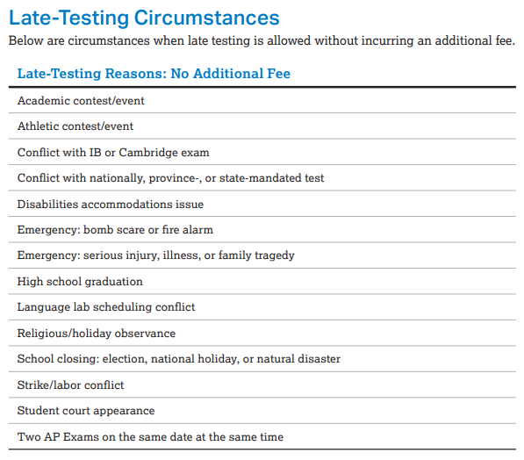
Qualifications for Late Exams
Depending on the reason for late testing, there may be an additional late-testing fee of $40 per exam charged to partially defray costs. When the cause of late testing is beyond the control of the school and the student, there is no additional fee. See the list (right) for late-testing reasons that don’t incur an additional fee.
Please note the following reasons which do NOT qualify for a late exam: personal preference, forgetting the original exam date, vacation, college visit, family event (including weddings and graduations), and non-school sponsored athletic event or academic contest. Students may NOT elect to pay a fee to arrange different exam dates based on any of these reasons.

Dates for Late Exams
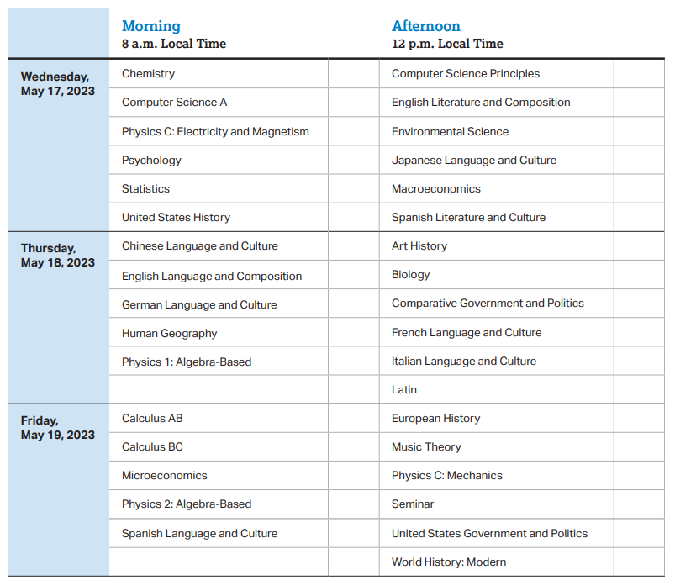

West High Process for Late Exams
Students who recognize a conflict with an AP exam date must alert Ms. Nick by March 10, 2023. College Board requests late exam registration by March 15, 2023. In order to process late testing requests, students will complete the AP Alternate Exams for Late Testing form for submission to Ms. Nick by March 10.

2022 – 2023 AP Coordinator’s Manual, page 29

